What is deep learning?

Deep learning is a subset of machine learning driven by multilayered neural networks whose design is inspired by the structure of the human brain. Deep learning models power most state-of-the-art artificial intelligence (AI) today, from computer vision and generative AI to self-driving cars and robotics.
Unlike the explicitly defined mathematical logic of traditional machine learning algorithms, the artificial neural networks of deep learning models comprise many interconnected layers of “neurons” that each perform a mathematical operation. By using machine learning to adjust the strength of the connections between individual neurons in adjacent layers—in other words, the varying model weights and biases—the network can be optimized to yield more accurate outputs. While neural networks and deep learning have become inextricably associated with one another, they are not strictly synonymous: “deep learning” refers to the training of models with at least 4 layers (though modern neural network architectures are often much “deeper” than that).
It’s this distributed, highly flexible and adjustable structure that explains deep learning’s incredible power and versatility. Imagine training data as data points scattered on a 2-dimensional graph, and the goal of model training to be finding a line that runs through each of those data points. Essentially, traditional machine learning aims to accomplish this using a single mathematical function that yields a single line (or curve); deep learning, on the other hand, can piece together an arbitrary number of smaller, individually adjustable lines to form the desired shape. Deep neural networks are universal approximators: it has been proven theoretically that for any function, there exists a neural network arrangement that can reproduce it.¹
Deep learning models are most commonly trained through supervised learning on labeled data to perform regression and classification tasks. But because large-scale neural networks usually require a massive amount of training data to reach optimal performance, the cost and labor of acquiring sufficiently large datasets of annotated training examples can be prohibitive. This has led to development of techniques to replicate supervised learning tasks using unlabeled data. The term self-supervised learning was coined by Yann LeCun in the late 2010s to disambiguate such methods from traditional unsupervised learning. Self-supervised learning has since emerged as a prominent mode of training neural networks, particularly for the foundation models underpinning generative AI.
Though neural networks (or analogous concepts) were introduced by data scientists early in the history of machine learning, their breakthrough didn’t begin in earnest until the late 2000s and early 2010s. The advent of deep learning networks across most subsets of machine learning was enabled in part by advancements in high-performance graphic processing units (GPUs) that enabled parallel processing of massive amounts of computational steps. Because deep learning requires a tremendous amount of computing power for both training and inference, these hardware advancements greatly increased the speed and practicality of implementing deep learning models at scale.

How it works (conceptually)
A deep learning model:
- Takes input data (images, text, sound, numbers)
- Passes it through multiple layers of artificial neurons
- Each layer extracts more complex features than the previous one
- Produces an output (prediction, classification, translation, etc.)
Example with images:
- First layers detect edges
- Middle layers detect shapes
- Final layers recognize objects (like faces or cars)

Common types of deep learning models
- Neural Networks (ANNs) – basic form
- Convolutional Neural Networks (CNNs) – great for images and video
- Recurrent Neural Networks (RNNs) – used for sequences like text or time series
- Transformers – power modern AI like ChatGPT and translation systems
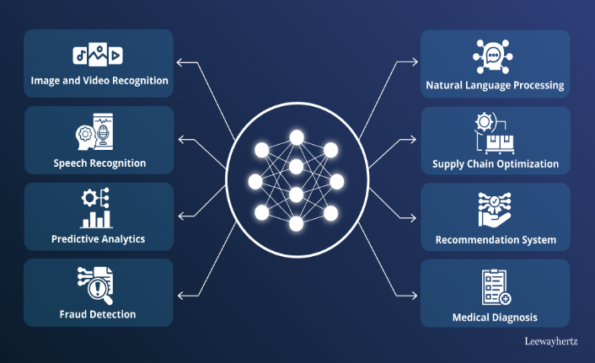

What is a Neural Network?

Neural networks are machine learning models that mimic the complex functions of the human brain. These models consist of interconnected nodes or neurons that process data, learn patterns and enable tasks such as pattern recognition and decision-making.

Neural networks are capable of learning and identifying patterns directly from data without pre-defined rules. These networks are built from several key components:
- Neurons: The basic units that receive inputs, each neuron is governed by a threshold and an activation function.
- Connections: Links between neurons that carry information, regulated by weights and biases.
- Weights and Biases: These parameters determine the strength and influence of connections.
- Propagation Functions: Mechanisms that help process and transfer data across layers of neurons.
- Learning Rule: The method that adjusts weights and biases over time to improve accuracy.

Learning in neural networks follows a structured, three-stage process:
- Input Computation: Data is fed into the network.
- Output Generation: Based on the current parameters, the network generates an output.
- Iterative Refinement: The network refines its output by adjusting weights and biases, gradually improving its performance on diverse tasks.
In an adaptive learning environment:
- The neural network is exposed to a simulated scenario or dataset.
- Parameters such as weights and biases are updated in response to new data or conditions.
- With each adjustment, the network’s response evolves allowing it to adapt effectively to different tasks or environments.

Importance of Neural Networks
- Identify Complex Patterns: Recognize intricate structures and relationships in data; adapt to dynamic and changing environments.
- Learn from Data: Handle vast datasets efficiently; improve performance with experience and retraining.
- Drive Key Technologies: Power natural language processing (NLP); enable self-driving vehicles; support automated decision-making systems.
- Boost Efficiency: Streamline workflows and processes; enhance productivity across industries.
- Backbone of AI: Serve as the core driver of artificial intelligence progress; continue shaping the future of technology and innovation.

Layers in Neural Network Architecture
Layers in Neural Network Architecture
- Input Layer: This is where the network receives its input data. Each input neuron in the layer corresponds to a feature in the input data.
- Hidden Layers: These layers perform most of the computational heavy lifting. A neural network can have one or multiple hidden layers. Each layer consists of units (neurons) that transform the inputs into something that the output layer can use.
- Output Layer: The final layer produces the output of the model. The format of these outputs varies depending on the specific task like classification, regression.

